**LAB # 02**

**Array List and Vector in JAVA**

**OBJECTIVE: To implement Array List and Vector.**

**LAB TASKS**

1. Write a program that initializes Vector with 10 integers in it. Display all the integers and sum of these integers.

**Code:**

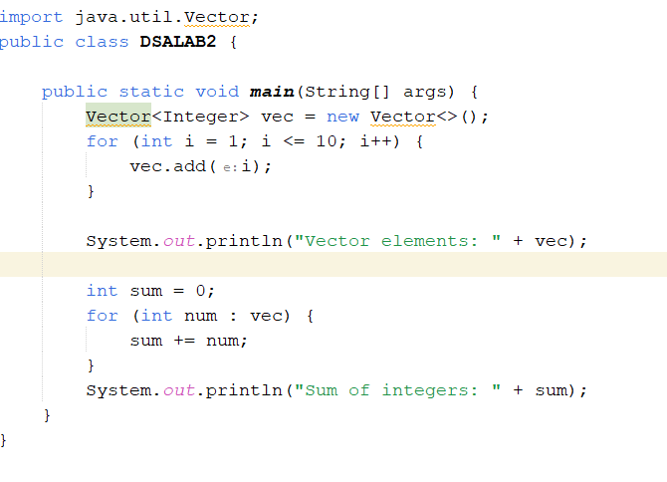

**Output:**

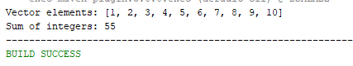

2. Create a Array List of string. Write a menu driven program which: a. Displays all the elements b. Displays the largest String.

**Code:**

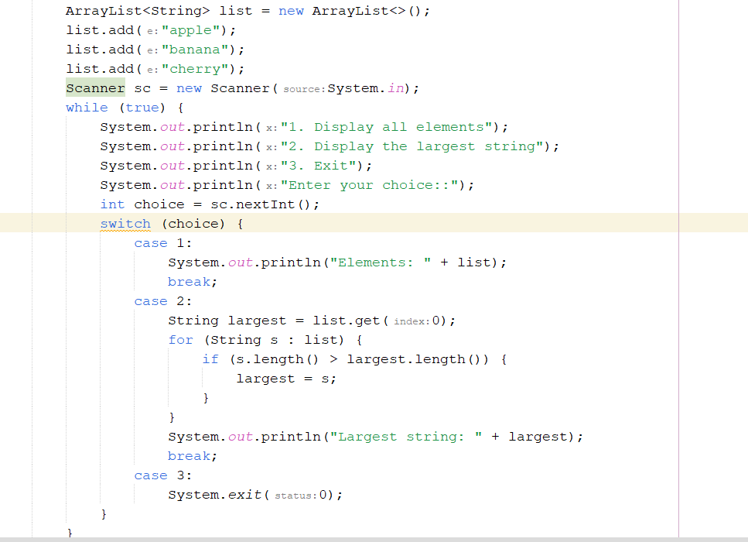

**Output:**

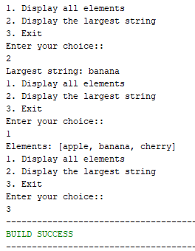

3.Create a Array list storing Employee details including Emp_id, Emp_Name, Emp_gender, Year_of_Joining (you can also add more attributes including these). Then sort the employees according to their joining year using Comparator and Comparable interfaces.

**Code:**

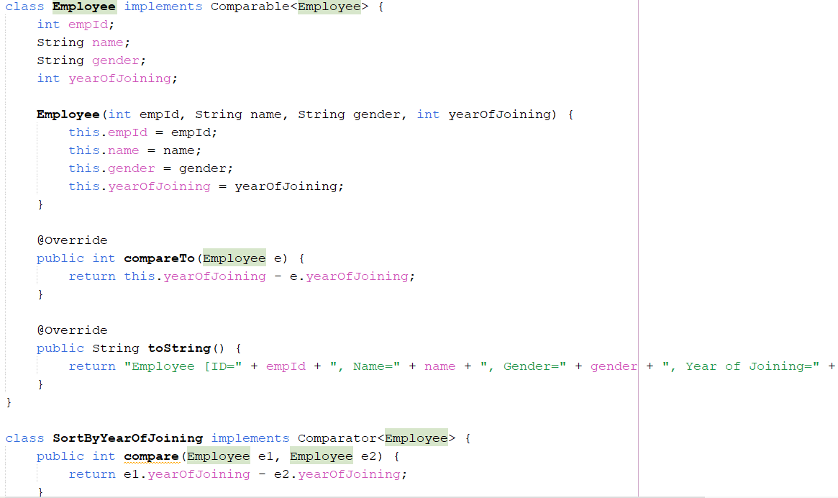

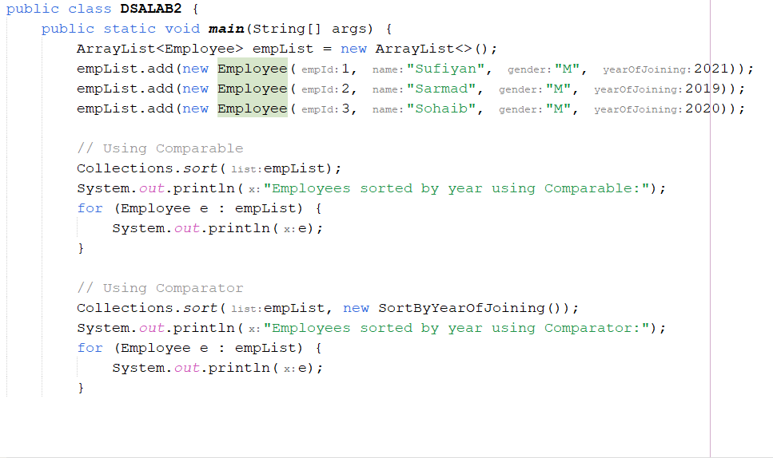

**Output:**

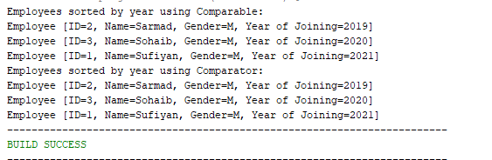

4. Write a program that initializes Vector with 10 integers in it.

• Display all the integers

• Sum of these integers.

• Find Maximum Element in Vector.

**Code:**

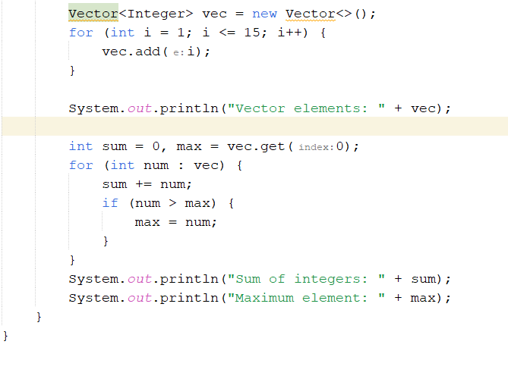

**Output:**

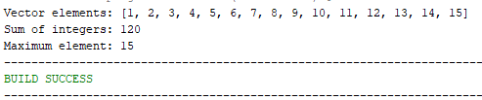

5. Find the k-th smallest element in a sorted Array List.

**Code:**

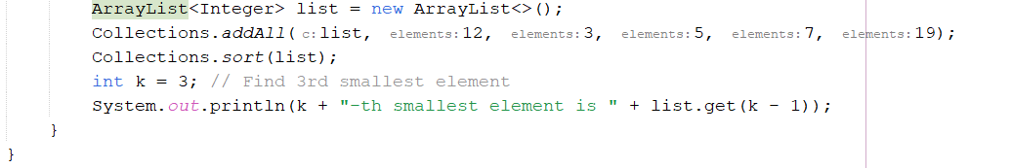

**Output:**



6. Write a program to merge two Array Lists into one.

**Code:**

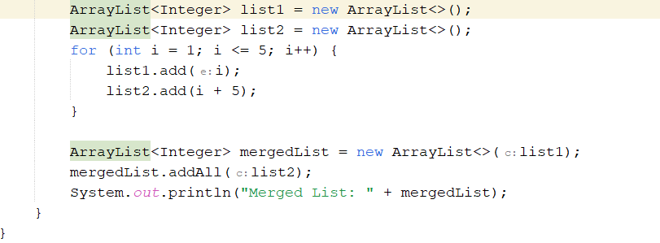

**Output:**



**HOME TASKS**

**1. Create a Vector storing integer objects as an input.**

a. Sort the vector

b. Display largest number

c. Display smallest number.

**Code:**

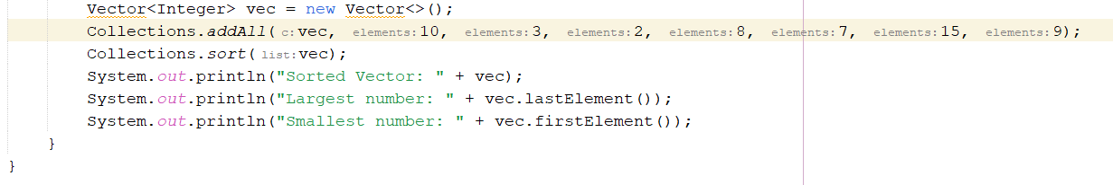

**Output:**

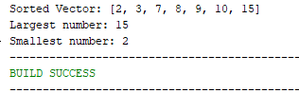

2.Write a java program which takes user input and gives hashcode value of those inputs using hashCode () method.

**Code:**

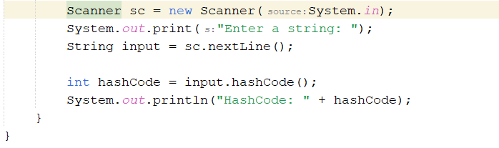

**Output:**

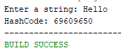3. **Scenario based**

Create a java project, suppose you work for a company that needs to manage a list of employees. Each employee has a unique combination of a name and an ID. Your goal is to ensure that you can track employees effectively and avoid duplicate entries in your system.

**Requirements :**

1. Employee Class: You need to create an Employee class that includes:

• name: The employee's name (String).

• id: The employee's unique identifier (int).

• Override the hashCode() and equals() methods to ensure that two employees are considered equal if they have the same name and id.

b. Employee Management: You will use a HashSet to store employee records. This will help you avoid duplicate entries.

c. Operations: Implement operations to:

• Add new employees to the record.

• Check if an employee already exists in the records.

• Display all employees.

**Code:**

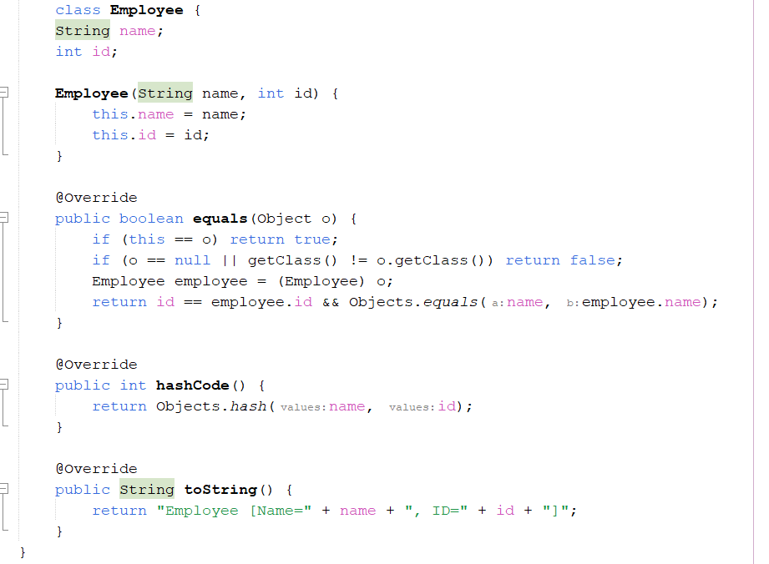

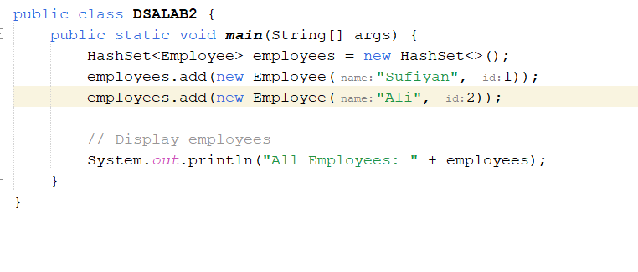

**Output:**



4.Create a Color class that has red, green, and blue values. Two colors are considered equal if their RGB values are the same.

**Code:**

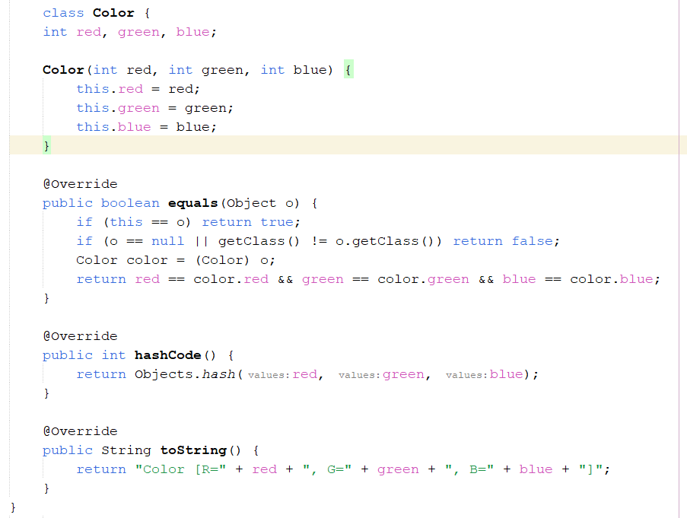

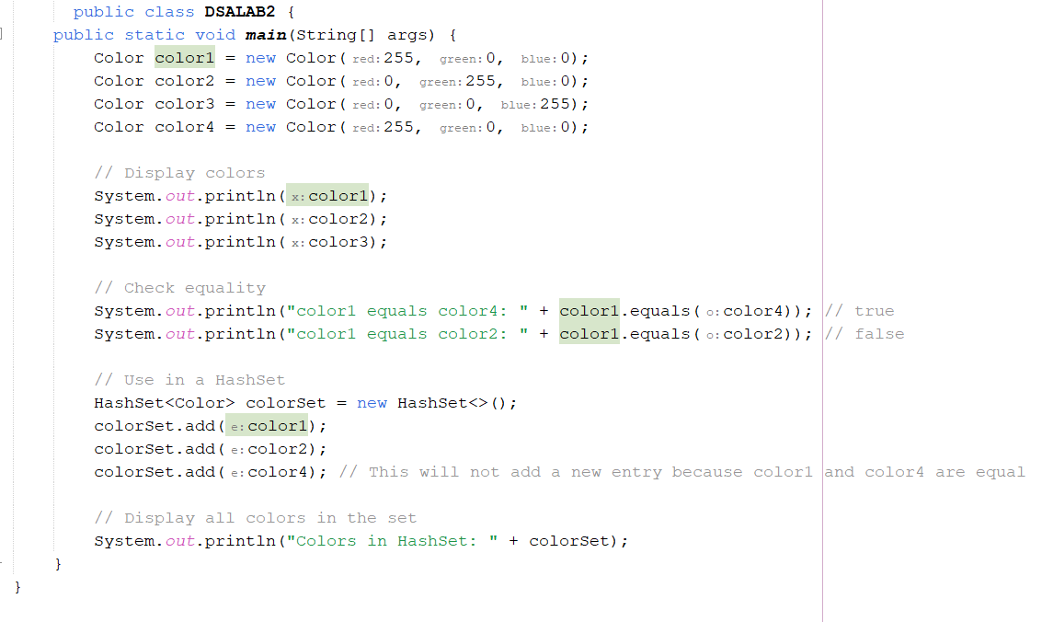 **Output :**

